Forces and Motion - Questions
June 2017 Mathematics Advanced Paper 1: Mechanics 1

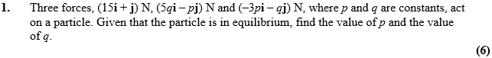

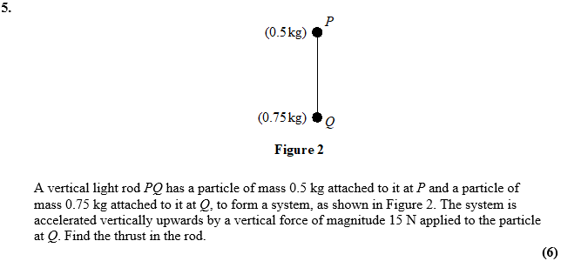

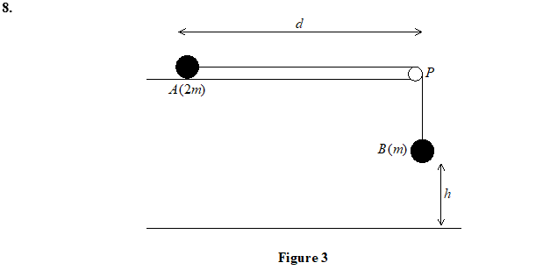
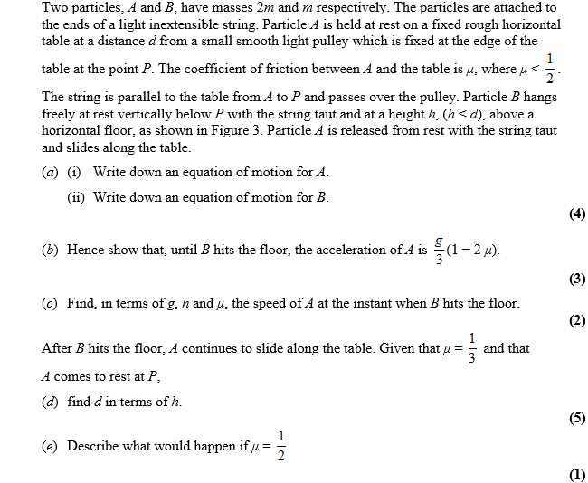

June 2016 Mathematics Advanced Paper 1: Mechanics 1

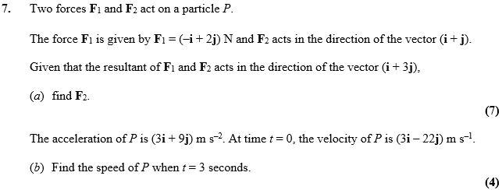

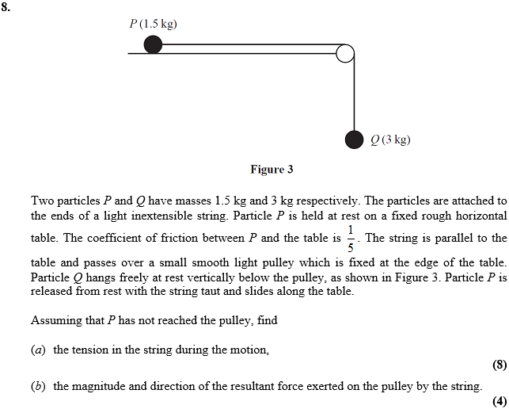
May 2014 Mathematics Advanced Paper 1: Mechanics 1

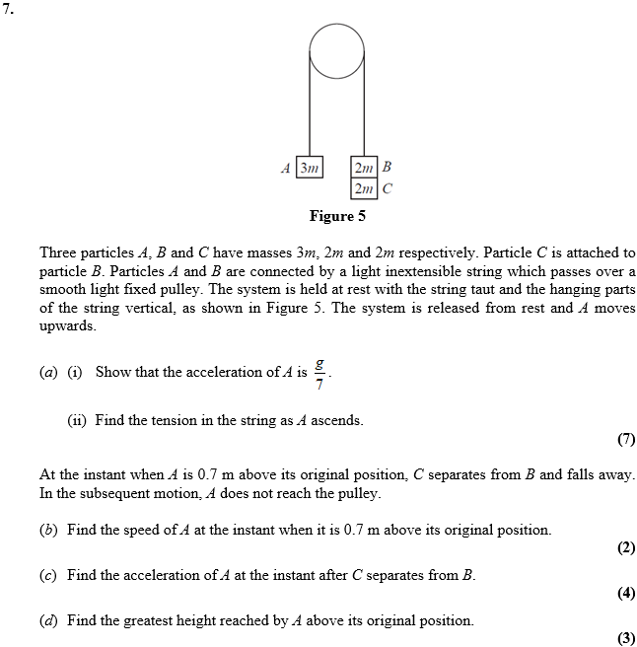

May 2013 Mathematics Advanced Paper 1: Mechanics 1

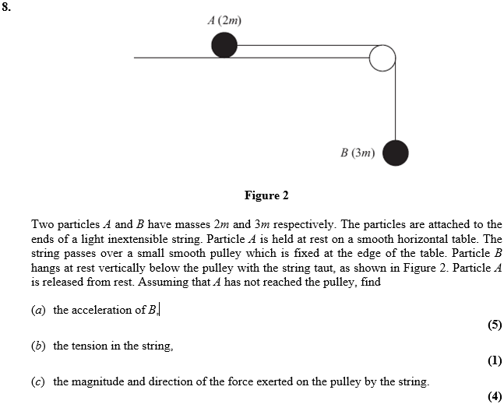

Jan 2013 Mathematics Advanced Paper 1: Mechanics 1

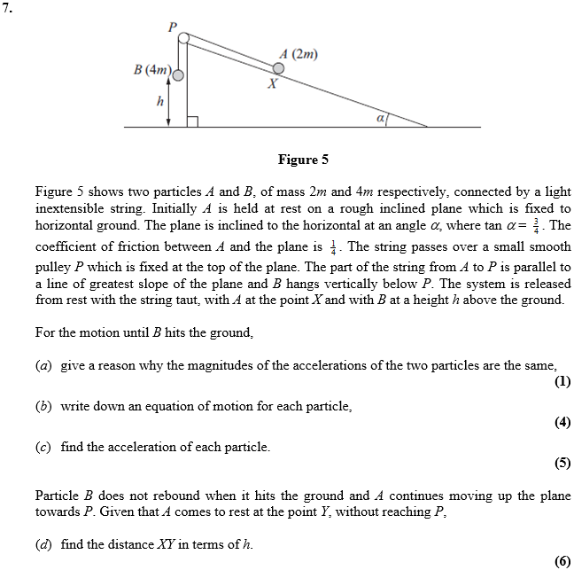

May 2012 Mathematics Advanced Paper 1: Mechanics 1

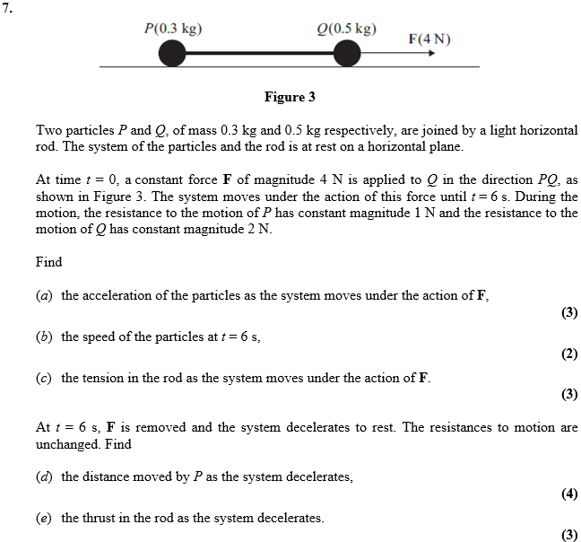

Jan 2012 Mathematics Advanced Paper 1: Mechanics 1

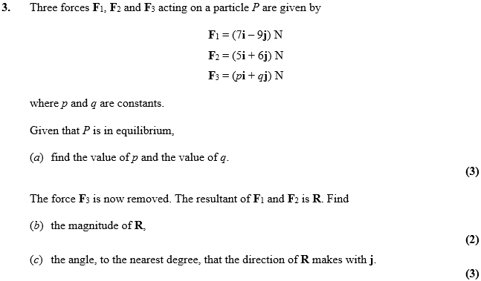

May 2011 Mathematics Advanced Paper 1: Mechanics 1

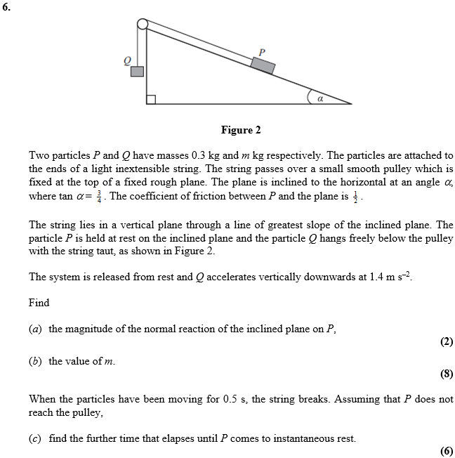

Jan 2011 Mathematics Advanced Paper 1: Mechanics 1

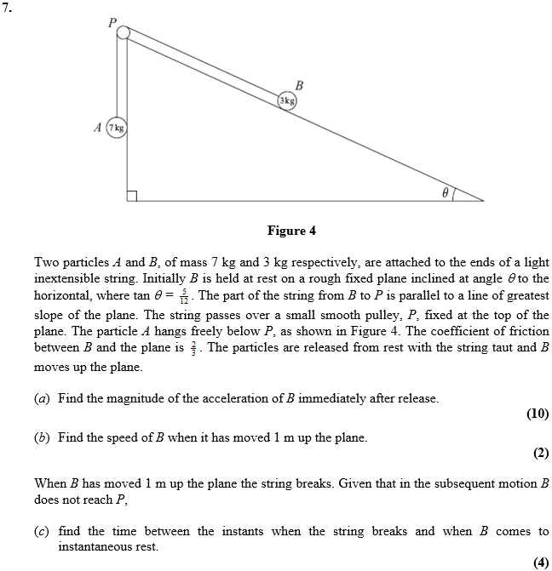

May 2010 Mathematics Advanced Paper 1: Mechanics 1

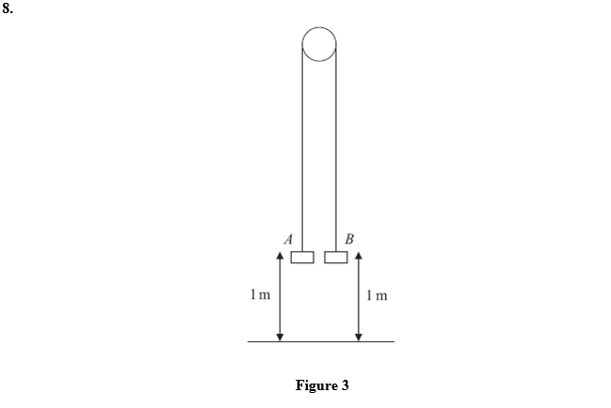
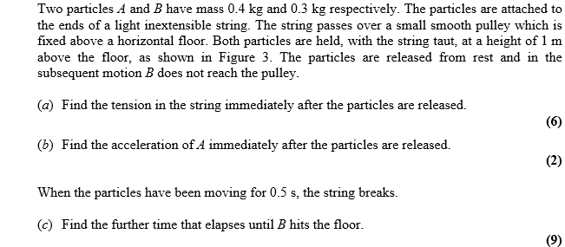

Jan 2010 Mathematics Advanced Paper 1: Mechanics 1

